Magic Invitational Report: Dan Clegg
Dan Clegg
It's been a while since I have had to a reason to actually write something.
I haven't been to school in quite a while, so I don't write papers anymore. I've thought about writing Magic articles before, but I'm not sure I have all that much to say, and if it's not going to be good, I don't want to bother. But I'll bother with this anyway. This is the Invitational we're talking about here. It was such an honor to be invited, and great to think, "wow, that could be me on that hot new rare in the next set". Forget business cards, I'd just carry one of those bad boys around with me, and when people asked what I did...WHABAM! I'd whip it right out. Would I really? Am I really that much of an egomaniac? I guess we'll never know, because Kai ended up winning our finals marathon match (7 hours: putting Dan Clegg in an important match with no time limits is bad news).

Putting Dan Clegg in an important match with no time limits is bad news...
Winning isn't what this tournament is truly about though. Granted, I wanted to win. I wanted to win bad. When Kai drew that Tinker in the last game of the tournament, my heart sunk. The main reason I wanted to win, though, was so I could come back next year. The whole experience was so much fun; I definitely recommend it to each and every one of you. The good folks showing us around Cape Town did everything they could to make it great, and they succeeded. Thanks a lot, guys.
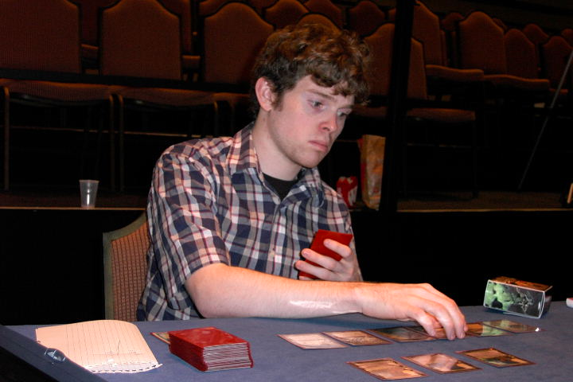
It all started off in the Atlanta airport, where I was to meet Brian Kibler and Chris Benafel. When I got there they were playing their 5-Color decks. At this point, I didn't yet have a 5-Color deck. Peter Szigeti (you may know him as ptr, the baddest man on the planet) sent me a 5C deck to play in the tournament, but it didn't get there in time. So I was going to have to do some serious scrounging in order to get a deck, but as Chris Benafel says, things tend to work out. I tried not to worry about that too much, and had a great breakfast and chatted with Brian and Chris. If you're ever in the international terminal of the Atlanta Airport, head over to the Chinese food place there for some killer egg sandwiches; they are truly the best in the world (and I think my man Brian will back me up on this).
The plane flight: long, long, long. That's all I really remember. 20-something hours. Not much else to say. When we finally arrived at the airport, we were greeted by Peter and Keith, our main guides to Cape Town. They told us all about what we were going to be doing that week, and how much our money was worth. To give you an idea of how much it was worth, most alcohol was about the same price as a soda is here in the USA, and steaks were 4 or 5 dollars. It was going to be tough to spend all the money we had brought along, but we were all determined to give it our best shot.
When we got to the hotel, we ran into Kai Budde and Gary Wise, who had arrived a day earlier. Kai told us that for some reason they had bought him a business-class ticket to the event! Some people have all the luck! After hanging out for a little while, we decided to go over to our hotel for some much-needed rest. On the way there we met Scott Richards (who I expected to be Latin, but actually wasn't at all!) and his friend James White, who is pretty much a riot. The rest of the day was a blur, up until the time a large group of us headed over to the Drum Cafe, where we pounded away on drums to our hearts' content. James had a long conversation with a local Rastafarian hanging out at the club, and good times were had by all.
The next day it was time to turn in our cards. After talking to some of the other players about what I should make, I decided with the help of Kai on this card:
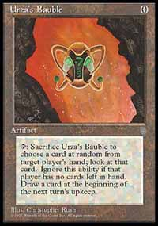
Not quite as good as Clegg's Bauble
Artifact, Casting cost: 0. Comes into play tapped. Sacrifice it to draw a card, or tap and sacrifice it for a colorless mana and a card.
Not too fancy, but it was good enough for me. Another idea was "Turtle Nation," suggested by my friend and PTNY teammate Lan D Ho, which would have been an enchantment that makes every creature in play a 1/4. But we decided that you would just get into these ridiculous standstills where all you can do is trick your opponent into attacking with all his guys first! So I had to go with the Bauble.
Fast forward to the tour day. The Ruels hadn't shown up yet, but everyone else was there and in full effect. Whether that is a good or bad thing is up to you. As it was already 11 o'clock in the morning, we headed over to a winery to do some wine tasting. I had never really had wine before, and I don't think I'm going to take up drinking it, but at least I can say I've wine-tasted now. After we finally got going from there (Matt Vienneau was having some trouble finding the bus), we headed into town for a quick lunch break. KFC is good. Then it was off to another winery. I guess that's what happens when you leave tour day up to the English! Although the lady leading the wine-tasting seemed to have something lodged somewhere rather unpleasant, this place was cooler, because just outside there was a place where you could pet cheetahs. Now that is a once in a lifetime experience. I got to pet a couple baby cheetahs, so did most everyone else, and then we were off! Off to the boat tour.
Ahh, the boat tour. It started off great. The air was crisp and cold, and the smell of the sea was refreshing. There had been rumors of it being a boat tour with topless waitresses, but we found out that Wizards has decided to go with the other option. Actually we found out about this earlier in the day, and a near riot broke out! But it was not to be. There was, however, a cute girl serving drinks. I got to talk with Dave Price about life, music, and such (side note: read his report if you haven't already; it's good). And the fabulous brothers had finally arrived. Those guys are a lot of fun.
But then... people started getting sick. A lot of people. I felt bad for them. It looked like about the worst thing ever. Then I started to get sick. It was about the worst thing ever! Not to mention that Matt Vienneau kept falling on me while I was lying frozen on the couch inside of the boat. I couldn't hold it too much against him, as he had conceded a match to me during Worlds where I was going to win next turn but couldn't due to time constraints; it got me the one extra Pro Tour point I needed to be invited to the Invitational. He apologized later on too, so that's all the Matt Vienneau bashing I'll do in this report!
When the long ride finally ended, everyone seemed happy to be on dry land again. We headed back to the hotel for a quick change and to freshen up for dinner, which was supposedly at a very cool restaurant. Mark Rosewater mentioned that if you were still feeling sick, you didn't have to go to the dinner. I wasn't feeling my best, so I opted to sit out. However, I felt a lot better after a quick shower, so I went downstairs to see if I could still catch the bus to the restaurant before it left. I got there just as it was pulling away, but it was too late. Luckily I ran into a couple nice South African folks who were also going to that dinner, who said they'd give me a ride there (I forgot your names, but thank you). The dinner was great. We got to try a variety of South African foods, and were treated to some live music and native dancing. Tsuyoshi Fujita also treated us to some dancing of his own, and let me tell you, he knows how to get down. And finally, after a long and tiring day, we headed off to bed.
Now on to the tournament! The first three rounds were Duplicate Sealed. We had an hour to construct our decks, but it was only at the last minute that I decided to go b-w. So please don't be too shocked when I tell you that I played a Dark Ritual in a format where everything cost one mana. Oops. That one got sided out after every game, along with The Rack (although it took me a little longer to realize that The Rack was no good), which never really did anything, because with everything costing one mana you could hold your land after you had enough out. This format was so-so I thought, because with the cards being so close in their power level it usually came down to who drew less land.

Round 1: Scott Richards
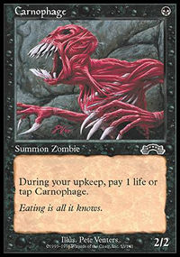
Scott had chosen to build a g-u-b deck, which he told me was a mistake after the match. I don't remember exactly what happened during the games, only that it went to two games, and that he had mana problems in the second game, where my turn one Carnophage went nearly all the way.
1-0

Round 2: Chris Pikula
Chris went with the w-b strategy as well, and he beat me 2-1. Mirror matchup, cards bounced off each other, he came out on top.
1-1

Round 3: Olivier Ruel
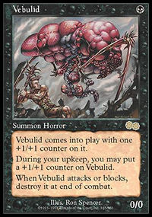
Olivier had an army of stuffed animals with him at the table, but I tried to remain unfazed. Still, they made me laugh. Our match went to three games, and I remember him having to Smite my Sleeper Agent (yeah I was running that beast) that I kept blocking with a Nomads en-Kor and redirecting to a big Vebulid. Ha HA! That was pretty funny. I ended up winning our match 2-1.
2-1
Next was the 5-Color format. Fortunately for myself, I had been able to scrounge something up. I was playing beatdown, and I was ready to beat down.

Round 4: Chris Benafel
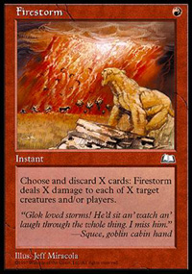
Chris was playing a Recur deck that used cards like Bazaar of Baghdad, Squee, Krovikan Horror, and Living Death among other things to gain a lot of card advantage and eventually win. The match went to three games, with the highlights being him beating me to a pulp the first game, him anteing a Moat in the second game and Intuitioning for Jeweled Bird rather than Firestorm (which would have killed my three creatures; I had four cards left in my hand), which let me win that game (they were all lands in my hand), and one turn in the last game where I Firestormed away his Birds of Paradise and Hermit Druit, cast Dark Ritual, Armageddon, and Contract from Below all in one turn, leaving me with seven cards to his one. Finally I beat Chris, which is pretty hard to do (yeah, he owns me). 3-1

Round 5: Gary Wise
Gary was playing a combo deck that won with Dream Halls, Sliver Queen, and Coalition Victory. Pretty cool other than the fact that I hate playing against combo decks. They're just sort of one sided, and some (like this one) take forever to go off. It's annoying sitting there while they go through the motions, and you hope for that small chance of them fizzling.
But it usually doesn't happen. Anyhow, our match went to three games, and I won in a squeaker. At least it felt that way; it usually does against combo decks because there's always the possibility of them killing you seemingly out of nowhere in one turn. We had sort of stupid dispute during the match about him wanting to look through and memorize a lot of cards that I had Consulted away. I was just kind of annoyed about how long it was taking, but he actually did have a right to look through them, so I should have been more tolerant.
4-1

Round 6: Tom van de Logt
Tom is a funny guy who was playing a funny deck. No dual lands. No power cards. It was a domain deck, actually. He beat me in two games, mostly due to Blood Moon. Ouch. So I ended up at 4-2 after Day 1.
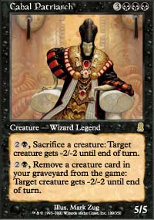
The second day started off with the Rotisserie Draft. All the cards from Odyssey were laid out on the table, and we took turns picking, with the drafting starting like a Rochester draft, wheeling with the 8th player, then coming back the other way and wheeling with the 1st player. Antoine Ruel started off by picking Aboshan, and as the 2nd player I took Cabal Patriarch. I had decided that I wanted to go b-u, so when it came around to me again, I took Shadowmage Infiltrator, and ended up with a deck I was very happy with.

Round 7: Antoine Ruel
Antoine had drafted a good g-u deck. I don't remember the exact details of the match, but after losing the first game I pulled out a win that I didn't think was going to happen in the 2nd by attacking for the win with a Pulsating Illusion enchanted with Patriarch's Desire (yes that's a 9/1 when you have threshold), and ended up winning the third game as well.
5-2

Round 8: Jon Finkel
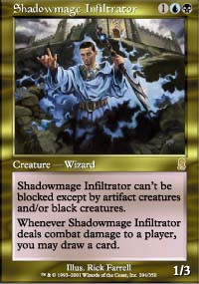
Everyone's beating Finkel with his own card!
Jon was playing a beatdown r-g deck. The games were pretty close, but I ended up winning. Ironically, the Shadowmage Infiltrator I had did a lot of the work for me. Thanks Jon!
6-2

Round 9: Dave Price
Dave was playing b-r with bombs like Savage Firecat and Stalking Bloodsucker. Basically he had some serious mana problems, and my Cabal Patriarch came out early both games, so I won 2-0.
7-2
Now it was time for some Standard. I decided to go with the Jon Finkel's w-u-b deck, based around Meddling Mage and Shadowmage Infiltrator.

Round 10: Tsuyoshi Fujita
Tsuyoshi was playing a combo deck based around Early Harvest, lots of mana, and Ghitu Fire/Death Grasp. Meddling Mage is hard for it to deal with, especially backed up with card drawing, Duress, and counters. I won 2-0.
8-2

Round 11: Kai Budde
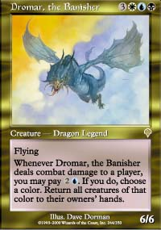
Kai was playing a u-b Opposition deck (though I didn't know it had Opposition in it at the time). First game he got out the first Infiltrator and I had nothing, so it was over fairly quickly. Second game I didn't have much, but he only had Memory Lapses for my Dromar. Eventually I got it into play, and it was holding off his medium-sized army of card-drawing creatures. A turn or two later I cast a Fact or Fiction, and the piles he chose were something like Vindicate and Fact or Fiction vs. Dromar and two other cards. So obviously I took the Dromar and played it next turn. Hold on, what's that you say? Dromar is a legend? Oops. That's what I get for not reading the card. Kai won, and was now in first place at 9-2, while I went to 8-3.

Round 12: Mike Pustilnik
Mike was play a deck based around Squirrel's Nest and Opposition. He drew a lot of land, and mine was pretty good against his with the disruption and Meddling Mages. I won 2-0.
9-3
So Kai and I were tied in first place at the end of the day at 9-3. I was starting to think I had a real shot at this tournament. The Auction of Champions was confusing, though. I didn't realize soon enough that you had to bid aggressively on decks, or you were going to get stuck with a bad one. Things got sort of panicky, and I ended up bidding a little too much on the Spies deck. 6 cards and 13 life to be exact. Ugh. Well, at least Scott Johns had only 10 life with his deck, so I thought I could win that match. Kamiel with the Minotaur deck and Brian with the Homarid deck were going to be tougher though.

Round 13: Scott Johns
Scott was trying to do me in with the Chicken deck. Game one I got him with Blood Oath. Game two he got me with a lot of Chickens. Game three Blood Oath again. Wheeee... 2-1.
10-3

Round 14: Kamiel Cornelissen
Kamiel had the Minoutars, and I did not have high hopes for this match. Game one, I managed to Blood Oath him out...hmm... Game two he just smashed me. Game three was actually very close, I needed to draw a creature in a few turns to block so I could kill him with Vexing Arcanix, but nothing came, so I lost 2-1.
10-4

Round 15: Brian Kibler
Brian had edt's deck: the Homarids. Game one I got some early beats with my spies, and finished him off with Blood Oath. I was sitting there thinking about casting it, about what I should call, for a few minutes... eventually he said "Dan, I have every type of card in my hand, show me Blood Oath and I'll concede" Somewhat relieved, I showed him the Oath. Game two I managed to kill him with my Spies. Holy crap, I was in the finals! Kai had beaten Scott Richards, so we were to face off.
The finals lasted a long time. Seven hours at least. You can read about it on the Sideboard, but basically what happened was that Kai beat me in the last game of the last match by casting a Jeweled Bird and making it impossible for me to win, due to the ante rules. Although I don't like that rule, it most likely won me my match against Chris Benafel. So live by it, die by it. Even though I wanted to win very much, Kai is very much deserving of being on a Magic card. Congratulations Kai. And thanks to all the players, Mark Rosewater, all the folks who showed us around town, Cutting Edge Collectibles for lending me all the cards I needed for decks, and everyone else who made the Invitational so much fun. Also, congratulations to Ben Seck for winning the Grand Prix! Hope to be doing this again next year. Hint hint.

